JAVA SELF-TEST QUESTIONS – CHAPTER 1 – GETTING STARTED

Question 1 | If the following statement were used in a Java program, it would cause something to be written to the screen. What would it cause to be written to the screen?  System.out.println("Java is not a drink.");
Answer | Java is not a drink.

Question 2 | Give a statement or statements that can be used in a Java program to write the following to the screen:  I like Java.  You like tea.
Answer | System.out.println(“I like Java.\nYou like tea.”);

Question 3 | Write a complete Java program that uses System.out.println to output the following to the screen when run:  Hello World!
Answer | public class HelloWorld{  public static void main(String[] str){  System.out.println(“Hello World!”);  }  }

Question 4 | What is a compiler?
Answer | A compiler is a program that converts or translates the whole source code into machine code at a time.

Question 5 | What is a source program?
Answer | A source program is the file containing the source code that is written in a programming language which is understood by human or the compiler/interpreter which can be later translated into the machine code and executed.

Question 6 | What is an object program?
Answer | Object program is the program code that is translated into the machine code from its equivalent source code by the compiler or interpreter.

Question 7 | What do you call a program that runs Java byte-code instructions?
Answer | Java Virtual Machine

Question 8 | Suppose you define a class named NiceClass in a file. What name should the file have?
Answer | NiceClass.java

Question 9 | Suppose you compile the class NiceClass. What will be the name of the file with the resulting byte-code?
Answer | NiceClass.class

Question 10 | Which of the following may be used as variable names in Java?  rate1, 1stPlayer, myprogram.java, long, TimeLimit, numberOfWindows
Answer | rate1, numberOfWindows

Question 11 | Can a Java program have two different variables named number and Number
Answer | Yes it can have two variable name number and Number as java is case sensitive language.

Question 12 | Give the declaration for two variables called feet and inches . Both variables are of type int and both are to be initialized to zero in the declaration.
Answer | int feet = 0;  int inches = 0;

Question 13 | Give the declaration for two variables called count and distance. count is of type int and is initialized to zero. distance is of type double and is initialized to 1.5 .
Answer | int count = 0;  double distance = 1.5;

Question 14 | Write a Java assignment statement that will set the value of the variable distance to the value of the variable time multiplied by 80. All variables are of type int.
Answer | int distance = time * 80;

Question 15 | Write a Java assignment statement that will set the value of the variable interest to the value of the variable balance multiplied by the value of the variable rate. The variables are of type double.
Answer | double interest = balance * rate;

Question 16 | What is the output produced by the following lines of program code?  char a, b;  a = 'b';  System.out.println(a);  b = 'c';  System.out.println(b);  a = b;  System.out.println(a);
Answer | b  c  c

Question 17 | Convert each of the following mathematical formulas to a Java expression:  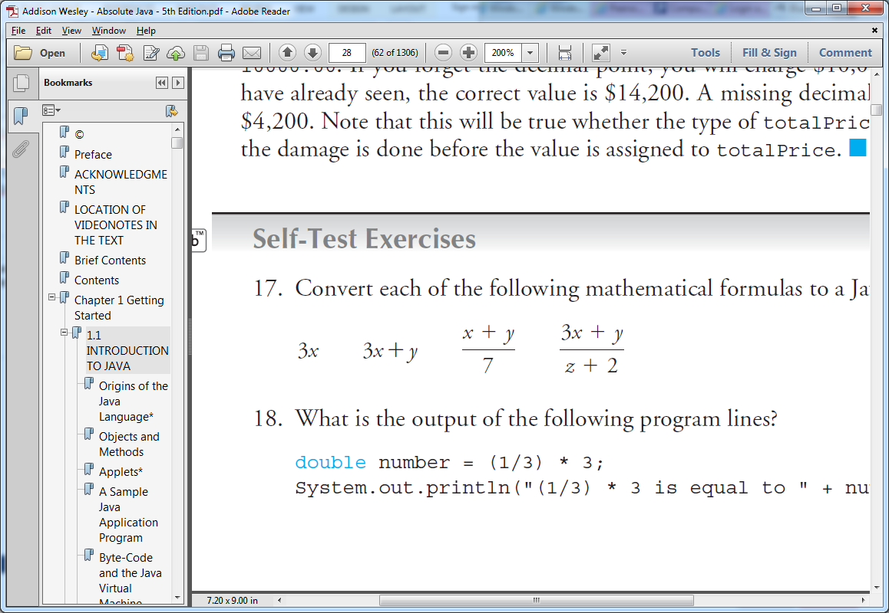
Answer | 3 * x;  3 * x + y;  (x + y ) / 7;  (3 * x + y) / ( z + 2 );

Question 18 | What is the output of the following program lines?  double number = (1/3) * 3;  System.out.println("(1/3) * 3 is equal to " + number);
Answer | (1/3) * 3 is equal to 1

Question 19 | What is the output produced by the following lines of program code?  int quotient, remainder;  quotient = 7 / 3;  remainder = 7 % 3;  System.out.println("quotient = " + quotient);  System.out.println("remainder = " + remainder);
Answer | quotient = 2  remainder = 1

Question 20 | What is the output produced by the following code?  int result = 11;  result /= 2;  System.out.println("result is " + result);
Answer | result is 5

Question 21 | Given the following fragment that purports to convert from degrees Celsius to degrees Fahrenheit, answer the following questions:  double celsius = 20;  double fahrenheit;  fahrenheit = (9 / 5) * celsius + 32.0;  a. What value is assigned to fahrenheit ?  b. Explain what is actually happening, and what the programmer likely wanted.  c. Rewrite the code as the programmer intended.
Answer | a: (9/5) * 20 + 32  b: variable celcius is initialized to 20, and another variable fahrenheit is assigned to the converted value of celsius to fahrenheit.  programmer is wanting to convert the temparature unit fro celcius to fahrenheit.  c:  public class TemperatureConverter{  public static void main(String[] args){  int celcius = 20;  float fahrenheit = (9/5) * cencius + 32;  System.out.println(fahrenheit);  }  }

Question 22 | What is the output produced by the following lines of program code?  int n = ( int)3.9;  System.out.println("n == " + n);
Answer | n == 3

Question 23 | What is the output produced by the following lines of program code?  int n = 3;  n++;  System.out.println("n == " + n);  n−−;  System.out.println("n == " + n);
Answer | n == 4  n == 3

Question 24 | What is the output produced by the following?  String verbPhrase = "is money";  System.out.println("Time" + verbPhrase);
Answer | Timeis money

Question 25 | What is the output produced by the following?  String test = "abcdefg";  System.out.println(test.length());  System.out.println(test.charAt(1));
Answer | 7  b

Question 26 | What is the output produced by the following?  String test = "abcdefg";  System.out.println(test.substring(3));
Answer | defg

Question 27 | What is the output produced by the following?  System.out.println("abc\ndef");
Answer | abc  def

Question 28 | What is the output produced by the following?  System.out.println("abc\\ndef");
Answer | abc\ndef

Question 29 | What is the output produced by the following?  String test = "Hello Tony";  test = test.toUpperCase();  System.out.println(test);
Answer | HELLO TONY

Question 30 | What is the output of the following two lines of Java code?  System.out.println("2 + 2 = " + (2 + 2));  System.out.println("2 + 2 = " + 2 + 2);
Answer | 2 + 2 = 4  2 + 2 = 22

Question 31 | Suppose sam is an object of a class named Person and suppose increaseAge is a method for the class Person that takes one argument that is an integer. How do you write an invocation of the method increaseAge using sam as the calling object and using the argument 10? The method increaseAge will change the data in sam so that it simulates sam aging by 10 years.
Answer | Person sam = new Person();  sam.increaseAge(10);

Question 32 | The following code is supposed to output the string in lowercase letters but it has an error. What is wrong?  String test = "WHY ARE YOU SHOUTING?";  test.toLowerCase();  System.out.println(test);
Answer | It is not assigning test.toLowerCase() output to any variable.  The correct method is:  test = test.toLowerCase();

Question 33 | What are the two kinds of comments in Java?
Answer | - single line comment  - multiline comment or block comment

Question 34 | What is the output produced by the following Java code?  /**  Code for Exercise.  */  System.out.println("Hello");  //System.out.print("Mr. or Ms. ");  System.out.println("Student");
Answer | Hello  Student

Question 35 | What is the normal spelling convention for named constants?
Answer | all the letters of the variable is uppercase.

Question 36 | Write a line of Java code that will give the name ANSWER to the int value 42.  In other words, make ANSWER a named constant for 42.
Answer | final int ANSWER = 42;

